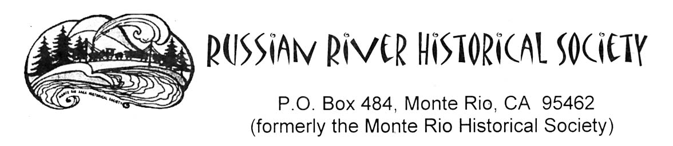

DIGITAL SCAN REQUEST & AGREEMENT FORM

Name:____________________________________ Organization:________________________
Address: _______________________________________________________________________
Phone: ___________________________________ Email:________________________________
Fax:_____________________________________

Statement Of Intended Use
(i.e., genealogy, dissertation, article, book, public exhibit, film, video, etc.)
________________________________________________________________________________________________________________________________________________________________________________________________________________________________________________________________________________________________________________________________________________________________________

AUTHORIZATION OF USE

This section when signed by authorized representative of the Russian River Historical Society constitutes written permission for the applicant to reproduce or use the image(s) described herein for the purpose specified in the “Statement of Intended Use”. A one-time exclusive right to print, publish or publicly exhibit the image(s) is granted in accordance with the conditions stated herein. Any violation of these conditions may result in denial of further service and/or action.

Permission for use authorized __________________day of______________,20______.

By________________________________________ (RRHS representative) Title________________________

PHOTO REPRINTS PHOTO SCAN
SIZE REPRODUCTION COST SCAN COST SCAN TO CD
5” x 7”.........................................$11.00 $15.00 per image ....... $15.00 per image +
8” x 10” .......................................$17.00 $8.00 per CD
11” x 14”......................................$27.00
16” x 20”......................................$45.00
20” x 24”......................................$57.00
24” x 30”......................................$90.00

CALIFORNIA SALES TAX OF 8% WILL BE ADDED TO THE TOTAL COST.

SHIPPING CHARGES ARE $10.

Note: Orders are filled only after receipt of this completed and signed form
and total payment as indicated below.

CONDITIONS
1. To use the photographic copy only once and only for the purpose listed in the “Statement of Intended Use” portion of
this form. Any subsequent or different use constitutes a reuse and must be applied for in writing.

2. We request for our permanent files, copies of any published work in which the photographic copy appears.

3. Not to permit others to reproduce the photographic copy or any facsimile of it.

4. Not to reproduce photographic copy as a dust jacket, an end paper or to use in any advertisement or any commercial
use of a similar nature, nor to mass produce as unbound material unless specifically authorized by a “Letter of
Permission”.

5. In authorizing the publication of a photographic copy, the Russian River Historical Society does not surrender its own right to
publish it, or to grant permission to others to do so.

6. Copyrighted material will ordinarily not be copied without the signed authorization of the copyright holder.
Applicants assume all responsibility for questions of copyright and invasion of privacy that may arise in copying and in
the use made of the photographic copy.

The Russian River Historical Society can claim only physical ownership of the image(s) described on this form.
It is impossible for us to determine fully or completely the identity of possible claimants of copyright.
The responsibility for identifying and satisfying copyright claims must be assumed by the user/publisher.

Our preferred credit line is: Courtesy, THE RUSSIAN RIVER HISTORICAL SOCIETY

NOTICE: WARNING CONCERNING COPYRIGHT RESTRICTIONS

The copyright law of the United States (Title 17, U.S, Code) governs the making of photocopies or other reproductions of copyrighted material. Under certain conditions specified in the law, libraries, & archives are authorized to furnish a photocopy or other reproduction. One of these specified conditions is that the photocopy or reproduction is not to be “used for any purpose other than private study, scholarship, or research”. If a user makes a request for, or later uses a photocopy or reproduction for purposes in excess of “Fair Use”, that user may be liable for copyright infringement. This institution reserves the right to refuse to accept a copying order of, in its judgment, fulfillment of the order would involve violation of the copyright law.

ORDER INFORMATION – REPRINT

QUANTITY SIZE CALL PHOTO NUMBER MATTE OR GLOSSY COST

ORDER INFORMATION – SCANNED IMAGE

CALL PHOTO NUMBER RESOLUTION FILE TYPE COST

Cost of Prints or Scans_______________________
Cost of CD_______________________
Personal Use_______________________
Commercial Use_______________________
Rush Charge_______________________
8% Sales Tax_______________________
Sub Total_______________________
Shipping_______________________

TOTAL $________________________

By signing this “Digital Scan Request & Agreement Form”, I agree that the photographs I have requested will be used only as I have indicated in the “Statement of Intended Use” portion of this form and further agree to all of the conditions, as stated herein and on the verso of this form.

Agreed to and approved this ___________day of _____________, 20___

By_______________________________________________ (applicant)

